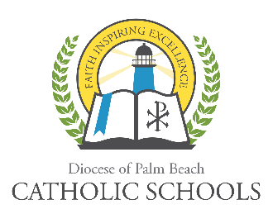
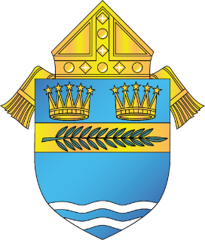

DIOCESE OF PALM BEACH
OFFICE OF CATHOLIC SCHOOLS NOTIFICATION

9995 N. Military Trail Telephone (561) 775-9500
Palm Beach Gardens, Florida 33410 www.DiocesePBSchools.org

DIOCESE OF PALM BEACH OFFICE OF CATHOLIC SCHOOLS CONTINUES TO MONITOR DEVELOPMENTS RELATED TO CORONAVIRUS
February 27, 2020
The Diocese of Palm Beach Office of Catholic Schools continues to monitor developments related to coronavirus. Protocols for medical emergencies are reviewed and updated as necessary in accordance with compliance with the Centers for Disease Control (CDC) and the Florida Department of Health.

The Centers for Disease Control suggest preventative actions such as: avoid close contact with people who are sick; avoid touching your eyes, nose and mouth; stay home when you are sick; cover your cough or sneeze with a tissue, then throw the tissue in the trash; clean and disinfect frequently touched objects and surfaces using a regular household cleaning spray or wipe; and wash your hands often with soap and water for at least 20 seconds, especially after going to the bathroom, before eating, and after blowing your nose, coughing or sneezing. The following links provide additional information: www.cdc.gov and www.floridahealth.gov.

The Diocese of Palm Beach will continue to work in close collaboration with public health officials and government agencies to address all concerns related to coronavirus, including promoting awareness and initiating additional responses if necessary.

During this development, and as always, the safety of the Diocese of Palm Beach faculty, staff, students and families are a top priority. Updates regarding how coronavirus could impact the schools of the Diocese of Palm Beach can be found on www.DiocesePBSchools.org or on the Office of Catholic School’s Facebook, Instagram and Twitter accounts @DoPBCatholicSchools.

###

