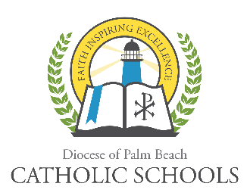
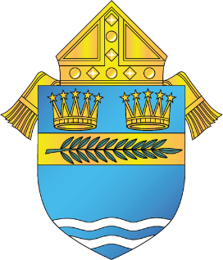

DIOCESE OF PALM BEACH
OFFICE OF CATHOLIC SCHOOLS NOTIFICATION

9995 N. Military Trail Telephone (561) 775-9500
Palm Beach Gardens, Florida 33410 www.DiocesePBSchools.org

A Note of Gratitude as We Conclude the 2019-20 School Year and Look Forward
May 19, 2020

First, let me express a sincere note of gratitude to everyone involved in Catholic schools across our diocese. We have all unified to work towards assisting the children in our Catholic schools in continuing their education for the last quarter of the school year. Teachers applied or learned new technology skills, parents assisted with instruction and supervision of children both day and night, and administrators found new ways to supervise that learning was occurring. However, our biggest heroes are the students themselves who managed to adapt and learn through all of this. Hopefully we have found that we can be our best selves in difficult times and we are stronger because of these changes! We are now in the home stretch -- we will all make it to the last day. Congratulations one and all!

I would also like to extend special note of congratulations to the Class of 2020! In these extraordinary times you have had graduation ceremonies like no other class. You will have stories to tell and memories from this moment that will make your graduation unique in the history of your high school and the greater community. Please know that we are proud of each and every one of you as you move forward!

This is not to say that the past few months have not been a challenge. Our lives and daily routines have been completely disrupted. We want to find our way back to where things were in January or at least to what is called the “new normal.” Many are unemployed, furloughed or have reduced income from less hours. If you find yourself in this position, please talk with your pastor or principal about financial aid and, in particular, look at the Florida state scholarship programs available at www.stepupforstudents.org/catholic. We want you to stay with us for the upcoming school year and keep our school families together!

What exactly will the coming school year look like? Our goal is that students will be back in their respective school buildings come the start of the 2020-21 school year in August. We are certainly monitoring other counties, states, and countries as their children return to school. We are working with our principals to review guidance as it comes out from our county, state and federal sources, including the CDC, the Florida Health Department, the Florida Department of Education and other resources. When schools re-open we will make every effort to provide a safe and secure environment for your child’s return to school. You can be assured that strict safety measures will be in place at each location.

We know that many dynamics will be in place as we resume classroom instruction. We are also looking at what options may be available to families who are not yet ready to have their child return to school. For example, in Norway, very few children ended up staying at home when they learned that their friends were back in school. The children put a lot of pressure on their parents to return to be with their friends. We know this will be a decision made by each family. We will have a plan in place that can be responsive to family needs, as well as to the changes the virus has caused within our communities.

We will carefully monitor how the virus reacts as our communities open back up and people begin to interact more and more. We will continue to let the doctors, researchers and data inform our decisions as we move forward. Given the unknown course the virus will take, our plans may have to be fluid and responsive so that we are prepared for every eventuality.

Prayers continue throughout our communities for all those impacted by the virus as well as for the safety of those in the healthcare and service sectors. Please know that you are always in our prayers. We can face this future using the Governor’s call to be Safe. Smart. Step by Step. As Most Reverend Gerald M. Barbarito said in re-opening our parishes and churches – “We will act with Prayer, Prudence and Patience.”

As always, the safety of the Diocese of Palm Beach faculty, staff, students and families are a top priority. Updates regarding how coronavirus could impact the schools of the Diocese of Palm Beach can be found on www.DiocesePBSchools.org or on the Office of Catholic School’s Facebook, Instagram and Twitter accounts @DoPBCatholicSchools.

Sincerely Yours in Christ,
Gary Gelo
Superintendent of Schools

###

