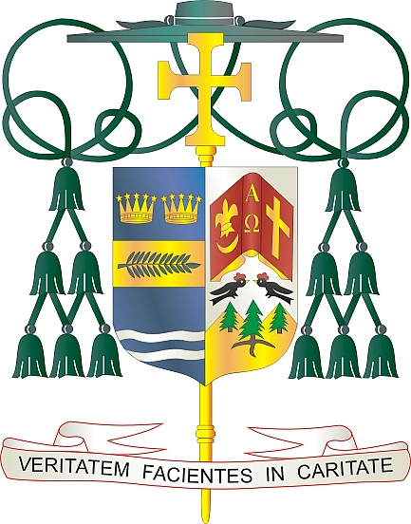
Office of
THE BISHOP

9995 North Military Trail • P.O. Box 109650
Palm Beach Gardens, Florida 33410-9650

(561) 775-9595 Fax (561) 775-7035

Diocese of Palm Beach

September 25, 2020

Dear Sisters and Brothers in Christ:
As we journey together through the current coronavirus pandemic, the Diocese of Palm Beach is working to stay in communication with the faithful of the diocese. One of the ways in which we do this is through The Florida Catholic.
The Florida Catholic is an important avenue to share the good news from our local parishes, schools, ministries, organizations, and the Catholic Church around the world. I value using The Florida Catholic as a platform to publish my column, “Living the Truth in Love,” to discuss various issues or faith teachings.
Some recent changes have occurred regarding The Florida Catholic. The publication has transitioned from a printed paper to an online version, now being offered free of charge every Friday at diocesepb.org. I encourage you to visit our diocesan website to read the latest in Catholic news, view photos from events in our diocese, watch videos featuring our parishes, and much more.
Also on our website, you will find a place where you can provide your contact information so that The Florida Catholic can stay in touch with you and, in the future, provide the news directly to your inbox.
I hope you will make reading The Florida Catholic a part of your week, as we strive to bring our faith family together to share the news—the Good News—that goes on around us.
With gratitude for your continued support and every prayerful wish, I am

Sincerely yours in Christ,
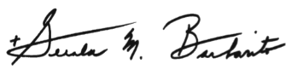

Most Reverend Gerald M. Barbarito
Bishop of Palm Beach

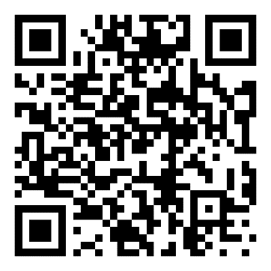

To visit our website and read The Florida Catholic now:
- Open the camera app on your cell phone or tablet
- Hold your device over the square to the left
- Follow the prompt on your device to open the website, www.DiocesePB.org/florida-catholic-newspaper

