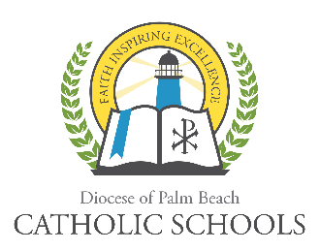
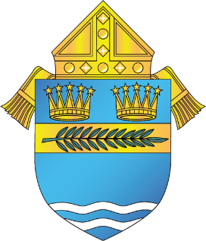

DIOCESE OF PALM BEACH
OFFICE OF CATHOLIC SCHOOLS NOTIFICATION

9995 N. Military Trail Telephone (561) 775-9500
Palm Beach Gardens, Florida 33410 www.DiocesePBSchools.org

DIOCESE OF PALM BEACH SCHOOLS CONTINUE THEIR VIRTUAL INSTRUCTION WITH SCHOOL CAMPUSES CLOSED THROUGH MAY 1, 2020
March 31, 2020

Most Reverend Gerald M. Barbarito, Bishop of Palm Beach, has extended the closure of the Catholic schools in the Diocese of Palm Beach through May 1, 2020. This does not apply to Rosarian Academy and Hope Rural School, which are private schools and will make their own determination. Virtual Instruction will continue at each of the diocesan schools through May 1, 2020.

As additional details become available, they will be shared through your local Catholic school. This is an ever-evolving situation and the diocese will provide you with information as quickly as possible. As always, the safety of the Diocese of Palm Beach faculty, staff, students and families is a top priority. Please visit our website www.diocesepbschools.org for the latest information.

The schools affected by this new protocol include:

Elementary Schools (12)
St. Helen Catholic School
St. Joseph Catholic School
St. Anastasia Catholic School
All Saints Catholic School
St. Clare Catholic School
St. Ann Catholic School
St. Juliana Catholic School
Sacred Heart Catholic School
St. Luke Catholic School
St. Vincent Ferrer Catholic School
St. Joan of Arc Catholic School
St. Jude Catholic School

High Schools (3)
Cardinal Newman High School
John Carroll High School
St. John Paul II Academy

