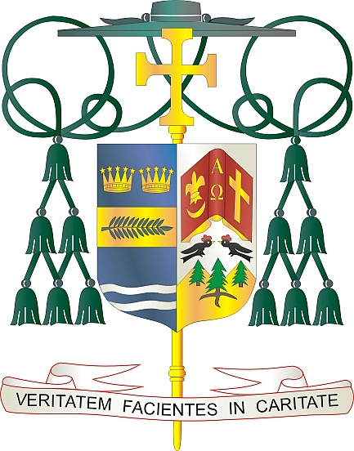
Office of
THE BISHOP

9995 North Military Trail • P.O. Box 109650
Palm Beach Gardens, Florida 33410-9650

(561) 775-9595 Fax (561) 775-7035

Diocese of Palm Beach

February 13, 2021

Dear Sisters and Brothers in Christ:

The Diocese of Palm Beach is blessed through the dedicated ministry of her priests. Many of these priests, because of age or infirmity, are no longer able to publicly assist at Mass, yet are nonetheless integral parts of our diocesan family. On February 20th and 21st each parish is invited to sponsor a second collection to support these faithful priests. In addition to supporting them financially, we also ask that you pray for our retired priests during this same weekend.

After years of dedicated ministry to our parishes, many of our retired priests in the diocese continue to serve their faithful through volunteer work and praying for our community. These priests, who have blessed us with their joyful service to the Lord, are valued members of our diocese now and always.

Let us remember the words prayed at a priest’s ordination: “Together with us, may they be faithful stewards of your mysteries, so that your people may be renewed in the waters of rebirth and nourished from your altar; so that sinners may be reconciled, and the sick raised up. May they be joined with us, Lord, in imploring your mercy for the people entrusted to their care and for all the world.” (Rites of Ordination, 2nd Edition, USSCB).

Your support of our retired priests through your prayers and generosity is greatly appreciated. Thank you in advance for allowing them to continue to be faithful stewards of God’s mysteries.

With gratitude for your continued generosity and every prayerful wish, I am

Sincerely yours in Christ,
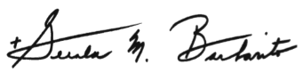

Most Reverend Gerald M. Barbarito
Bishop of Palm Beach

NOTE TO PASTORS: IT IS REQUIRED THAT YOU PUBLISH THIS LETTER IN THE PARISH BULLETIN AS A HALF PAGE OR FULL-PAGE LETTER THE WEEKEND OF FEBRUARY 13/14, 2021. THE COLLECTION WILL TAKE PLACE FEBRUARY 20/21, 2021. YOU ARE WELCOME TO READ THE LETTER TO PARISHIONERS, POST THIS LETTER ON SOCIAL MEDIA, AND ON YOUR WEBSITE IN ADDITION TO HAVING IT PRINTED IN THE BULLETIN.

