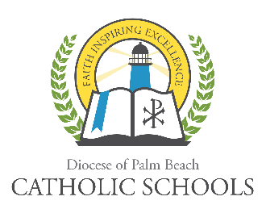
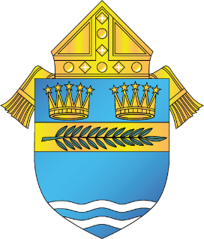

DIOCESE OF PALM BEACH
OFFICE OF CATHOLIC SCHOOLS NOTIFICATION

9995 N. Military Trail Telephone (561) 775-9500
Palm Beach Gardens, Florida 33410 www.DiocesePBSchools.org

DIOCESE OF PALM BEACH OFFICE OF CATHOLIC SCHOOLS CONTINUES VIRTUAL INSTRUCTION THROUGH THE END OF SCHOOL YEAR

April 18, 2020

The Diocese of Palm Beach Office of Catholic Schools will continue virtual instruction for our K-12 schools through the end of the current school year following the directives of Governor Ron DeSantis for all K-12 schools in the state of Florida.

Our entire Catholic school community -- pastors, administrators, teachers, staff, parents, guardians, and most importantly, students are to be commended for their efforts to work together to make virtual instruction in our Catholic schools an ongoing success. There have been a few bumps in the road and there have been a few difficulties, but school staff are always willing to work students and their parents to resolve these issues. Our Catholic school communities can be very proud of this collaborative effort over the last few weeks. United together in Christ we are accomplishing Something Greater for the children we serve!

Prayers continue throughout all of our school communities for those impacted by the virus and for the safety of those in the health care and service sectors. Know that you are always in our prayers as we have all been truly “Safer at Home” at this time.

As always, the safety of the Diocese of Palm Beach faculty, staff, students and families is a top priority. Updates regarding how coronavirus impacts the schools of the Diocese of Palm Beach can be found on www.DiocesePBSchools.org or on the Office of Catholic School’s Facebook, Instagram and Twitter accounts @DoPBCatholicSchools.

###

