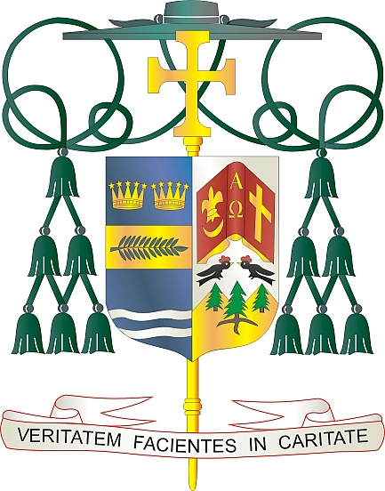
Office of
THE BISHOP

9995 North Military Trail • P.O. Box 109650
Palm Beach Gardens, Florida 33410-9650

(561) 775-9595 Fax (561) 775-7035

Diocese of Palm Beach

March 6, 2021

Dear Sisters and Brothers in Christ:

Next weekend, March 13-14, 2021 is the annual Diocese of Palm Beach collection for the education of seminarians and the formation of priests. The priestly discernment and seminary formation process are important, and these seminarians need our spiritual and financial support. The funds raised in this collection are used to support the cost of tuition, housing, education, and pastoral training of our seminarians.

Currently, there are eight seminarians from our Diocese who are dedicating themselves to this important process of understanding their vocation. With God’s grace, we will have three ordinations this year: one priestly ordination (Rev. Mr. Alain Waterman) and two diaconate ordinations (Mr. Armando Leon and Mr. Daniel Donohue). I thank you for your prayers for an increase in vocations and for these men. I assure you those prayers are working.

By your generosity, our seminarians can devote themselves fully to the task of priestly formation, without having to worry about the financial concern of seminary. With them, you walk the journey of faith and ensure that the sacraments will continue to nourish the faithful for generations to come.

Jesus said to his disciples, “The harvest is abundant, but the laborers are few; so ask the master of the harvest to send out laborers for his harvest” (Lk 10:2). Thank you for all that you do to ensure that the Church will always have worthy laborers at the harvest.

With gratitude for your continued generosity and every prayerful wish, I am

Sincerely yours in Christ,
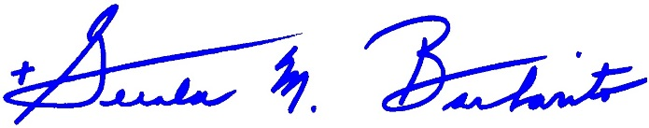
Most Reverend Gerald M. Barbarito
Bishop of Palm Beach

NOTE TO PASTORS: IT IS REQUIRED THAT YOU PUBLISH THIS LETTER IN THE PARISH BULLETIN AS A HALF PAGE OR FULL-PAGE LETTER THE WEEKEND OF MARCH 6/7, 2021. THE COLLECTION WILL TAKE PLACE MARCH 13/14, 2021. YOU ARE WELCOME TO READ THE LETTER TO PARISHIONERS, POST THIS LETTER ON SOCIAL MEDIA, AND ON YOUR WEBSITE IN ADDITION TO HAVING IT PRINTED IN THE BULLETIN.

